Q1. Explain StringBuilder class in java programming?

Ans:

The StringBuilder class is exactly same as StringBuffer class except the following difference

1. All methods of StringBuffer class are synchronized. Hence StringBuffer class are thread Safe.(one- one trnsation )
2. NO Methods of StringBuilder class are synchronized. Hence StringBuilder are not thread safe.(all transation do be with one)

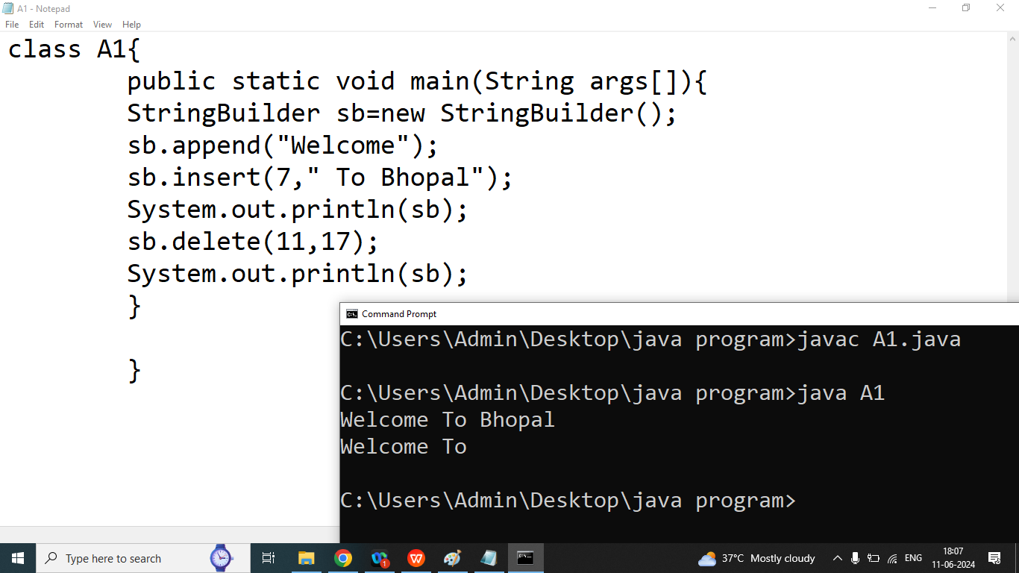

**String:** if our content are fixed and we won’t perform some modification then we should go for String class.String class is Immutable class

**StringBuffer:** if our content are not fixed and we want to perform some modification and thread safety is required then we should go for StringBuffer class.

StringBuffer class is a mutable.

**StringBuilder:**if our content are not fixed and we want to perform some modification and thread safety is not required then we should go for StringBuilder class.

StringBuilder class is a mutable

**Next class Topic: Array, Methods/Functions, OOPS,Exception Handling**

**Next Module:**

**MYSQL/SQL/Database**

**JDBC**

**Project Task**

**DSA Using Java**

**Our Own Logic**

**Linear Data Structure**

1. **Array**
2. **Stack**
3. **Queue**
4. **LinkedList**

**Sorting:**

1. **Insertion Sort**
2. **Bubble Sort**
3. **Selection Sort**
4. **Merge Sort**
5. **Quick Sort**

**Searching**

1. **Linear Search**
2. **Binary Search**

**NON-Linear Data Structure**

**Tree**

**Graph**

**Pre-defined Logic(Collection )**

**Collection Framework**

**Multithreading**

**Servlet**

**JSP  
=============================**

**Hibernate**

**SpringBoot**